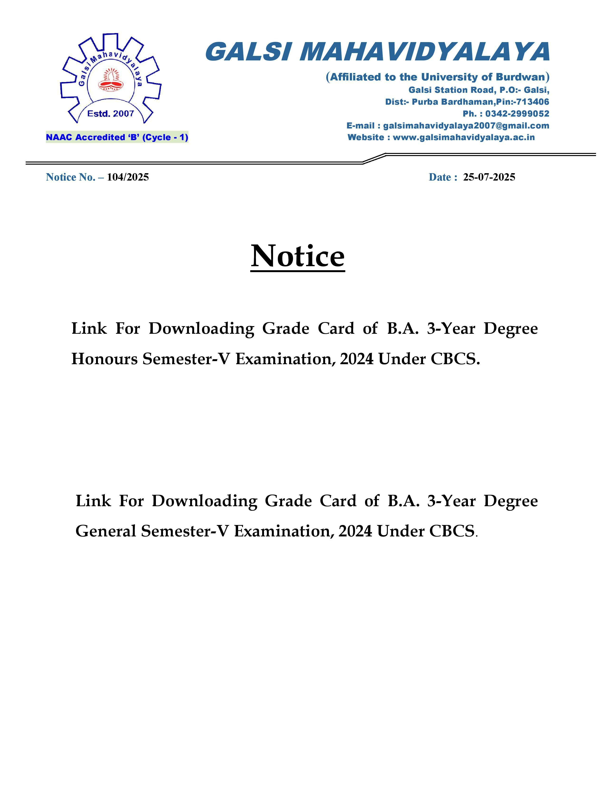

<https://drive.google.com/file/d/1t5AK2wIli8OljOKbNWjSW3u8mj3tq5CV/view?usp=sharing>

<https://drive.google.com/file/d/1EvTb7tECy4MtfFOtu4DSchJPu2B4bzZC/view?usp=drive_link>

